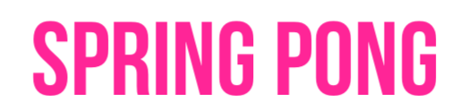

Thanks for your purchase.

If you don’t see the « Tools » in the top of the Unity Screen, please do this :

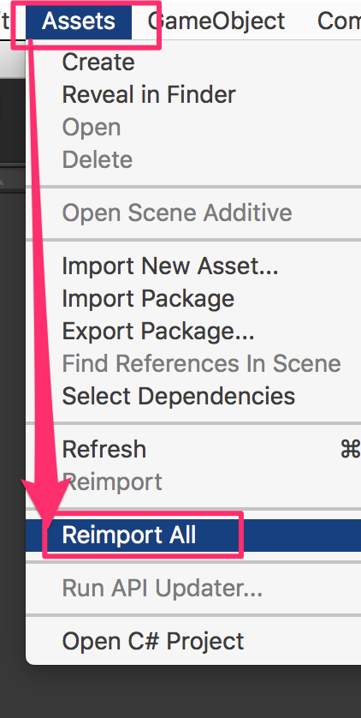

Now you have the « Tools ». Open it and click on « DOTween Utility Panel ».

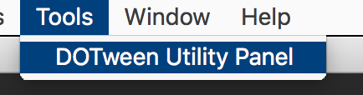

5/Click on « Setup DOTween ».

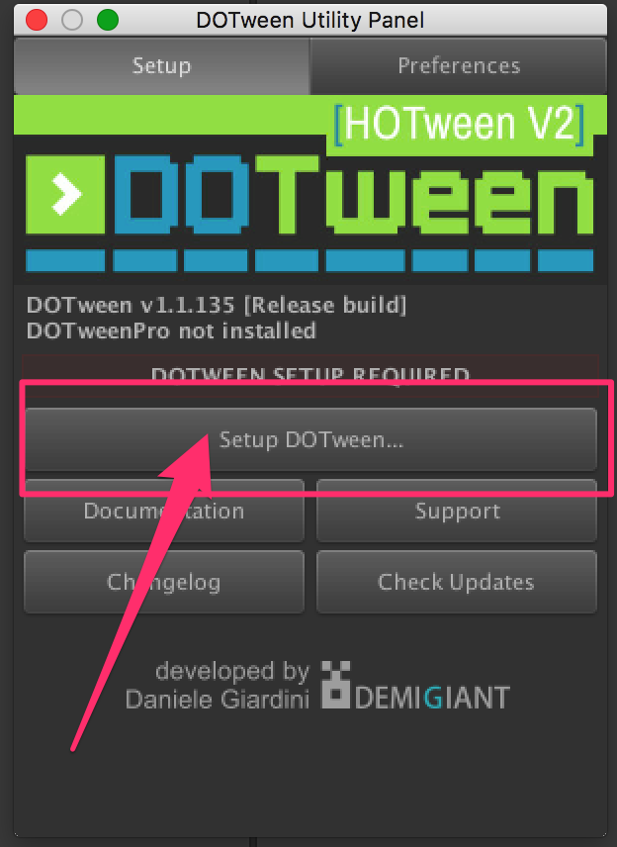

6/And to finish, click on the « OK » button.

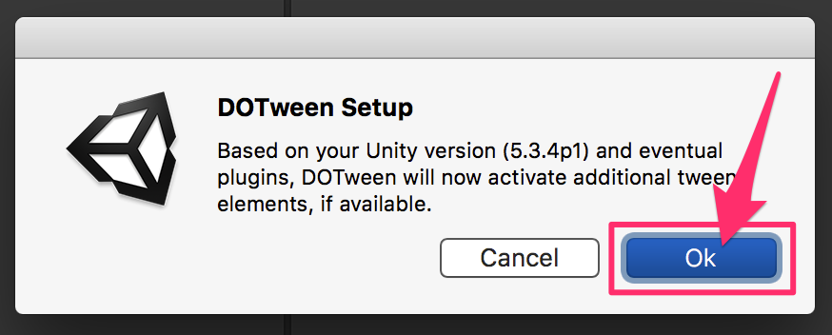

To begin, open the scene :

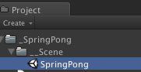

Hierarchy :

There is 4 dots in the screens, moved by the player :

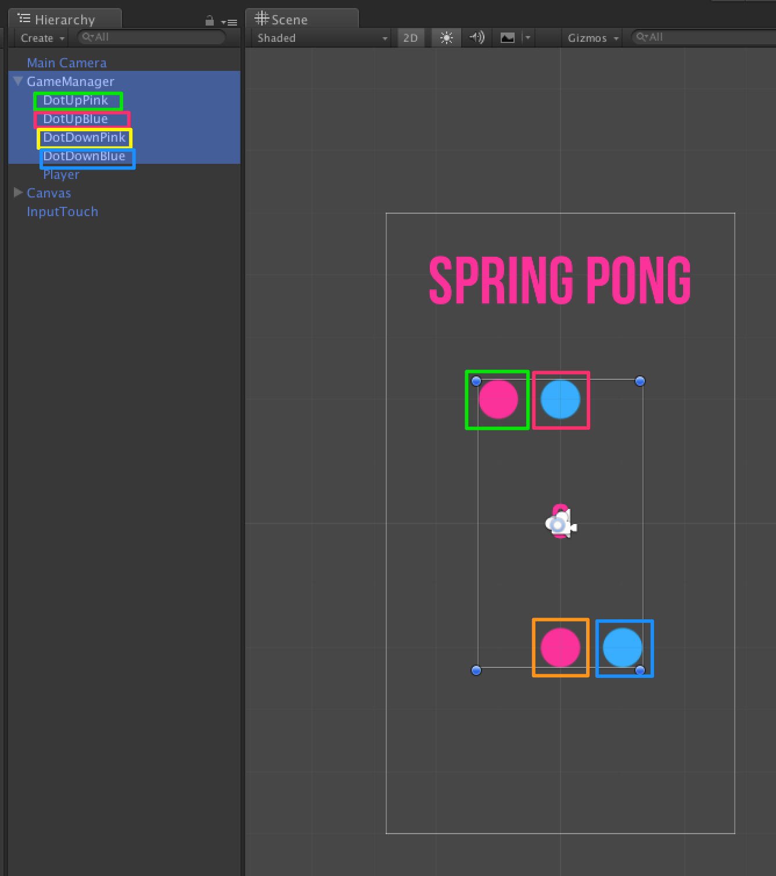

And the payer :

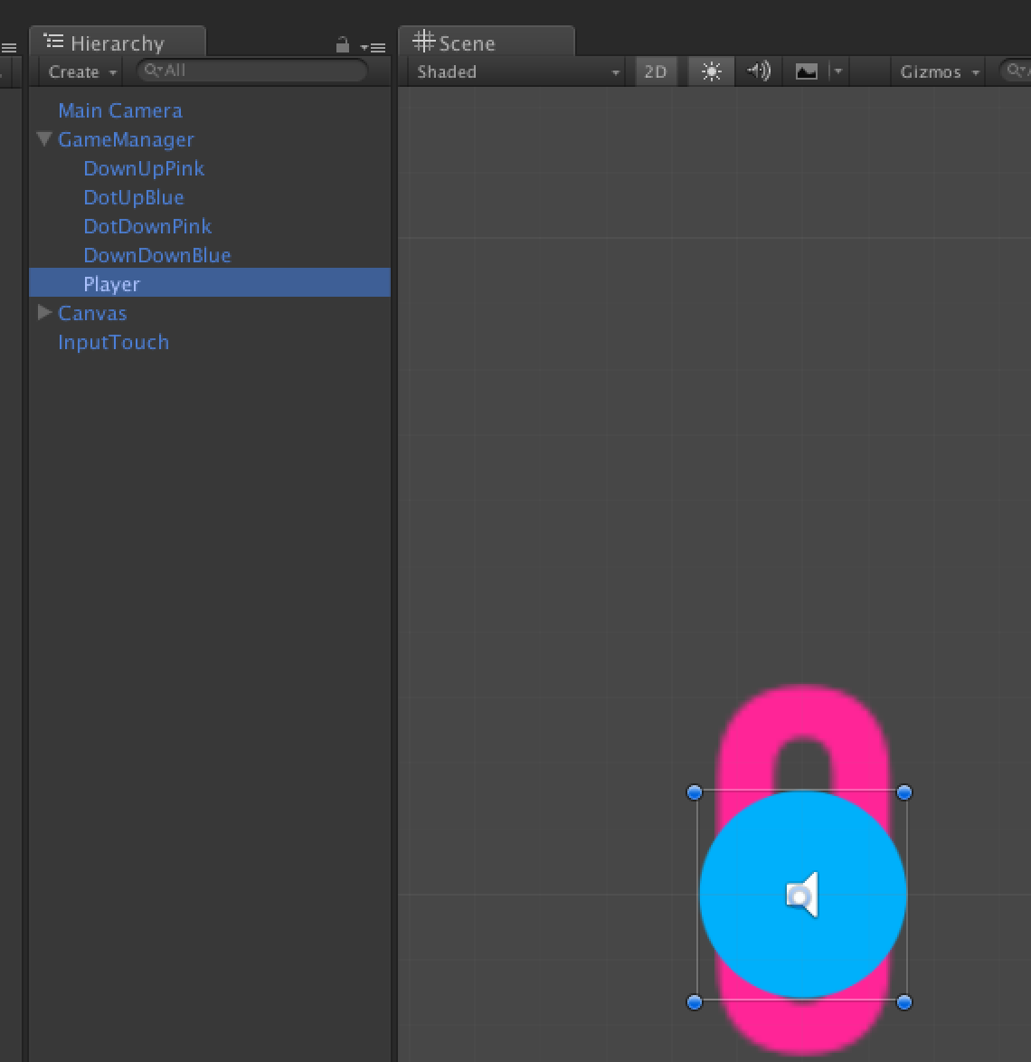

All are referenced in the GameManager :

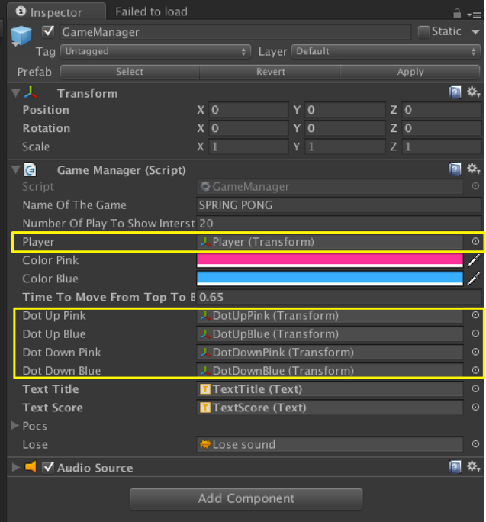

**Customization**

**CHANGE THE IMAGES:**

The easiest way is to open this image directly and modify it.

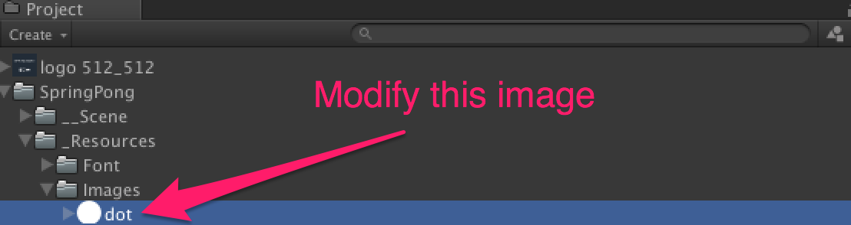

You can also add your own image and modify it directly into the GameObject. To modify the DotUpPink for exemple, select it on the hierarchy and drop your sprite in the sprite renderer :

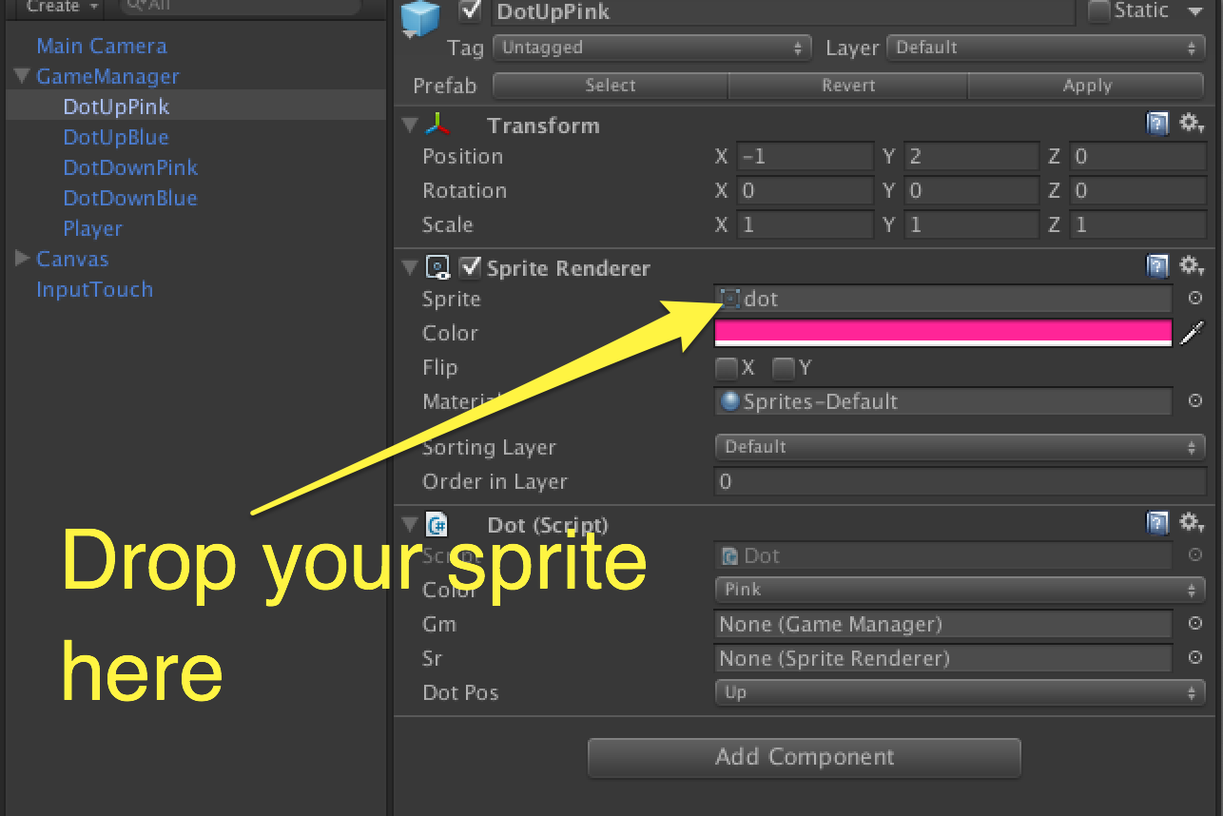

**CHANGE THE COLORS:**

The game works with two colors. If you want to change them : 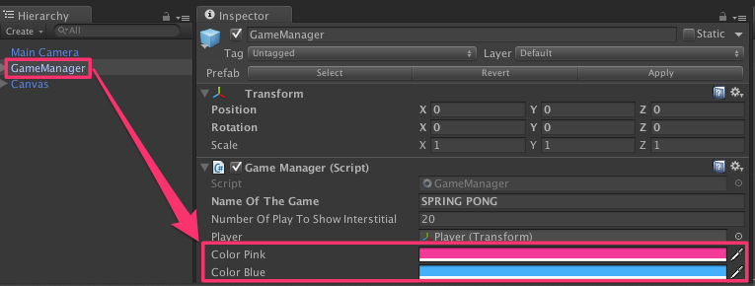

**CHANGE THE DIFFICULTY:**

The game difficulty is function of the speed of the ball. TO change it, change the viariable « Time To Move From Top To Bottom »:

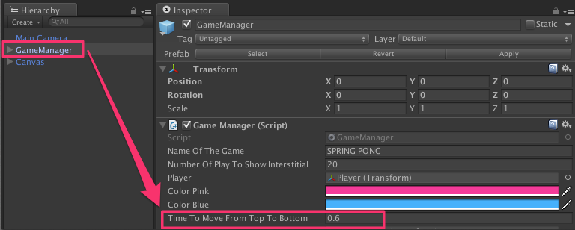

**ADS :**

Everything is done for you : « Very Simple Ads » is already implemented.

Get it here : http://u3d.as/oWD

**LEADERBOARD :**

Have a look to « Very Simple Leaderboard » : <http://u3d.as/qxf>

Thanks !

Our other assets : <http://u3d.as/9cs>

Contact : [contact@app-advisory.com](mailto:contact@app-advisory.com)